Assignment 10

IMPORTANT NOTES/REQUIREMENTS:

- Before attempting the assignment, make sure to read the chapter and slides for the week. Use the techniques introduced in the chapter to complete the assignment.
- This assignment uses the “test” database that was created in the assignment for Week 9.

- All steps are to be completed using Transact-SQL (T-sql code) instead of using the graphical user interface in SSMS.

- When you run your script, test the various pieces incrementally instead of waiting until the end of all steps to test. To execute just part of the script, highlight the given statement(s) of interest prior to clicking Execute.

- To save as a script in SQL Server Management Studio, choose File -> Save As… The file extension will be .sql for a saved script.
- Submit your script (.sql file) to the drop box for this week.

Assignment Steps

- Ensure that you are working in the “test” database by adding a USE statement to the top of your script.
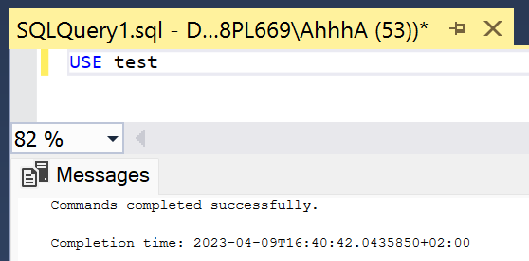

- In your script, create a schema named “Admin”.
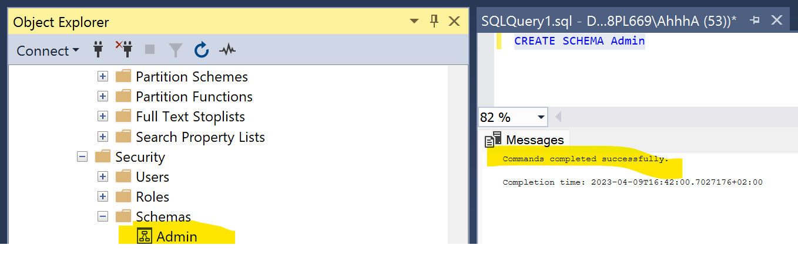

- Transfer the table called “Categories” from the current schema of “Production” to the new schema “Admin”.
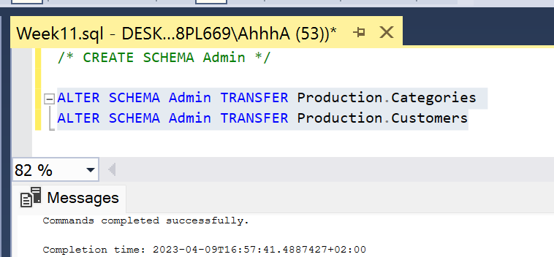

- Create a login ID named “JanetRhodes” with the password “HelloJanetR!” where JanetRhodes uses a default database of test.
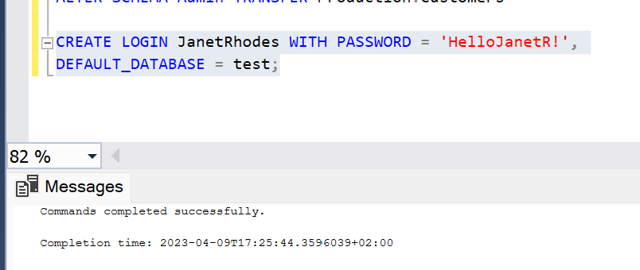

- Create a user named “JanetRhodes” that corresponds to the login that you created in the previous step.
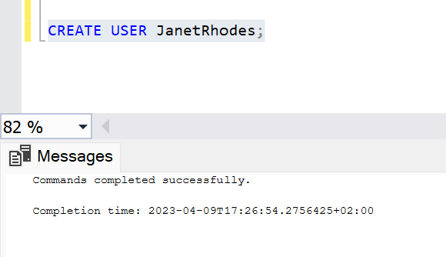

- Create a user-defined database role named “SELECTPriv”
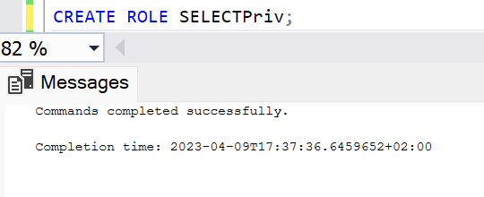

- Add select permissions to the user-defined database role “SELECTPriv” created in the previous step. Note that this is at the database-level.

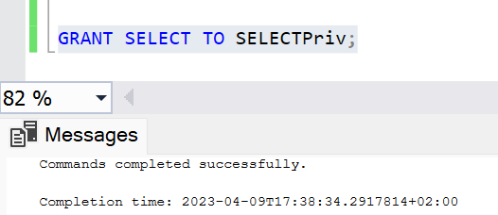

- Add the user “JanetRhodes” to the role “SELECTPriv”.
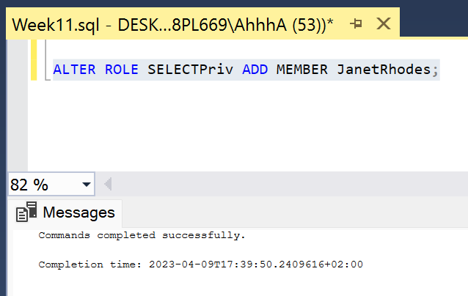

- If JanetRhodes would log in using SQL Server authentication, would she be able to execute the following statement without errors in the test database? As a second part of this question, answer why or why not. Note, you should be able to log into SSMS with SQL Server authentication using the loginid/password from step 4 if you would like to try this out.

SELECT * from Admin.Categories;

Yes, Janet would be able to execute that statement because she has select permission throughout the entire database.

- If JanetRhodes would log in, would she be able to execute the following statement without errors in the test database? As a second part of this question, answer why or why not. Note, you should be able to log into SSMS with SQL Server authentication using the loginid/password from step 4 if you would like to try this out.

DELETE FROM Admin.Categories;

Janet wouldn’t be able to execute this statement since she does not have delete permission.

